PROJECT REPORT

Multimodal Sentiment Analysis Using CNN and Transformer based Models

Submitted in partial fulfillment of the requirements
for the award of the degree of

Master of Technology
(2024-26, 3st Sem, Batch-1)

Under the supervision of: Submitted By:

Dr.Dheerendra Singh Anirudh Manoj
Professor (SCSET)


Plot Nos 8-11, TechZone 2, Greater Noida, Uttar Pradesh 201310
2024-26

Abstract.
In the current landscape, sentiment analysis has become a vital tool for industries aiming to improve their products and retain cus- tomers. For movie reviews, IMDb ratings often rely solely on textual data analysis, which may not fully capture public sentiment. To address this limitation, it is essential to incorporate multimodal data, include- ing text, images, and audio. Present research explores sentiment analysis by enhancing textual and image data. We will employ ten deep learn- ing(CNN and transformer) models such as RoBERTa,Swin Transformer, Vision Transformer, EfficientNetb6, EfficientNetb6, EfficientNetb5, Effi- cientNetb4, EfficientNetb3, EfficientNetb0 and MobileNetV2 to extract textual features, training each model individually. For image feature extraction, we will utilize both CNN and transformer-based architec- tures.We will analyze and compare the performance of these models and propose a fusion strategy that combines the most effective models. The use of transfer learning with pre-trained models will be central to this approach.This paper will discuss the challenges of feature extraction and the complexities of model fusion, focusing on how the different architec- tures interact and complement each other. The unique building blocks and intricate layers within each model type pose challenges but also of- fer opportunities for innovative fusion strategies to improve sentiment analysis.
Keywords: Deep learning, Image understanding, Multimodal sentiment analysis, Transfer learning.

Introduction

Now a days data is a oil which produces extremely fast way and machine learning is a engine which runs on it. Sources of data like social media, emails, tweets,
texts etc. these are the example textual data and with advancing technology form of data is also changing like image and video, video contains image as well as audio. So analysis these type of data show new challenges. Sources of images and videos are such as you tube, facebook, movies twitter etc. these data sets introduces more complexity as compare to textual data. Data which contains image and text or in other words data encapsuled with more than one type of data are termed as multimedia data[1-3]. As Yadollahi et al[4] highlighted that extracting features from text to know sentiment of of users has strong research and practice, and dealing with images also has intermediate level of success but not as text. this is the reason why sentiment analysis played very crucial role, when election comes political parties wants to know public view or review for their parties, then sentiment analysis comes in frame, Retail and E-commerce are such platforms which continuously analyses their users and test their sentiment so that retailers can know opinions of costumers about their purchasing experi- ence[1].Now a days creation of data set is extremely fast, analysing multimedia data to know sentiments by manually is impossible [5]therefore multimedia me- dia sentiment analysis become a new way to analyse opinion of people. So in this paper we perform multimodel sentiment analysis using text and image, and after getting sufficient result we will step into the combination of two features text and image. multimodel sentiment analysis introduces new challenges and complexities. in text we have used movie reviews data set which are labeled with two classes. while in image i have more than three classification but be- cause we used only two classes in text so to make pair with image classes we reduces the variety of classes and considered only those ones which is in text. today’s social media talked with multimedia data, new generations changes the mode of comments, ways of showing there opinions, emotions etc, the data pro- duced by there responses is more multimedia as compare to single media data set, So while checking and testing sentiments on only single type of data set will provide inaccurate result which is not beneficial for companies. therefore to counter this problem new technique comes in frame which was already de- scribed. multimedia data set provide enough accuracy of sentiments of users, and it will provide impactful role in decision making. organization and compa- nies will make changes according to the outcome of the sentiment analysis, they will consider users suggestion while making strategies[1-3]. in our research paper we use deep learning models to fetch features from input images and texts data set, deep learning models like Xception, mobilenetv2, efficientnetb0 etc., these models can learn and perform well in facial emotion recognition. Convolutional layers are termed as convolutional filters which are sliding over the input data, they are fully connected layers. CNN is branch of deep learning model which is used in image processing where hierarchy information of images is important, that why we prefer CNN approach for facial recognition. there are already so many research have been done on multimodel sentiment analysis[4,6-8] but it still facing challenges. image-text sentiment analysis is a branch of multimodel sentiment analysis, which is ongoing research topic. in this paper we also tried to

get sufficient accuracy and to make our model outperform from state-of-the-art method.

Literature Review
Sentiment analysis has been a topic of interest in research community from the last couple of decades. Medhat et al. (2014) reviewed and highlighted the potential research and application in sentiment analysis domain [20]. Recent work with deep learning models on sentiment analysis is producing a fast and efficient method [21].
Ahuja et. al. uses customized multimedia data set, the data set contains image as well text, approx 2k data set have been taken and annotation perform manually[5]. classification usually perform in three classes (positive, negative and neutral) several deep learning algorithms applied on created data set which extracted the image features with their associated labels, the main goal was to select best performing model. images contains textual features as well, image contain the same meaning as in text but having visual form, model of single modality can confuse or fail to classify actual sentiment if applied on multimedia data set because some time in multimedia data set, texts are written with positive sentiment but image shows the feature of negative sentiment. This problem can be resolve significantly by using multimodality model[9-11].
Taking overview of literature or previous published papers gives comprehen- sive analysis about the growth of methodology and theories of various branches of multimodel sentiment analysis. there is a paper in which author worked on tweeter data set, 7]tweeter data set are contains the reviews or opinions of pub- lic on any events or brand, in this only text feature was mentioned in analyz- ing sentiments natural language processing (NLP) and machine learning were used, firstly they clean or preprocess the data set like tokenization, eliminating the outlier, Normalization and other distracting parts. the goal was to classify the data into three category positive, negative and neutral based on the senti- ment, emotion or behaviour of the give text. after cleaning conversion of text into digital form was performed, before giving to machine learning algorithm or model like support vector machine text has to be convert in digital representa- tion. There are several methods available like word embedding, bag-of-word and Time-Inverse Document frequency. Deep learning models like short-term neural network (LSTM), Convolution Neural Network (CNN) and bidirectional Long- Short Term Memory these models were used in sentiment analysis, and they got successful results in training accuracy but was lagging in testing accuracy.

Methodology
We have used transformer and CNN models to extract features from the given input(image + text), features will help in model learning. transformer models are such as swin transformer and vision trasformer[12] these models shows the excellent performance. On the other hand CNN models were also performed

well, like efficientNetb5[13] successfully achieved the accuracy of 0.82 and other statistics are up to the mark.

Dataset

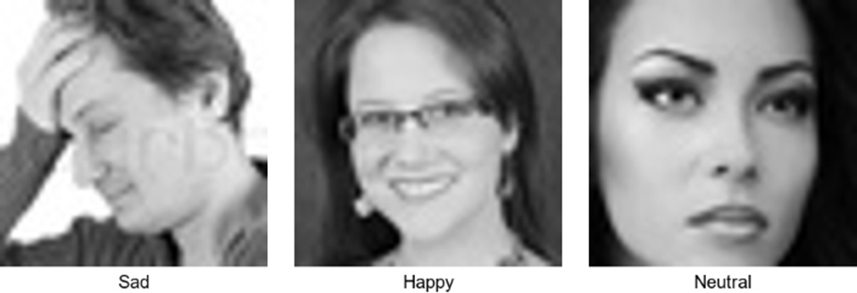

Fig. 1. An Example of Multimedia Data

To implement the deep learning models for sentiment analysis, a publically available dataset fer2013 has been used[14], in which seven classes are available, data set is divided into seven category positive,sad,disgust,fear, surprise, neutral and angry. we have implemented all ten deep learning models for training on the fer2013[14] data set, deep learning models have complex architectures as com- pare to machine learning models, machine learning models are not bad choice but because of data complexity it takes large computational time and might be fail to learn well hierarchal information or features. Deep learning models like Xception[15], MobilenetV2[16], EffiecientNetb0[13] etc.In Xception model layers work sequentially means information fetched from data by passing from top to bottom layer or last layer each layer having weights which updates af- ter getting new feature. Convolutional layers are termed as convolutional filters which are sliding over the input data, they are fully connected layers. the given fig3 shows the sample of fer2013 image data set, in which three classes are de- fined. The original resolution of images is 48 by 48, which is extended to 224 by 224 in data preprocessing for training the models. Instead of using all seven vectors of image data we have used only three positive, sad and neutral, because in text data set there are only three category or classes. in this paper we have first train the CNN and transformer model on facial expressions like positive expression, sad and neutral. The size of data set is approximately 18k, (training
+ validation) for training each features having 5k data set while in validation each feature associated with 1200 images.

    - Text Data Description for Textual data set, IMDB reviews and pos- itive X (formerly known as twitter.com) comments are taken, these data set are available on kaggle. IMDB movie reviews are classified into two sentiments pos- itive and negative, classes are balanced and well labeled. the size of data set is 50k with 25k each classes. In textual feature extraction we have chosen Deep

learning approach, deep learning models. RoBERTa is the replacement of BERT model[17], it developed from BERT by making some changes like eliminating next-sentence pretraining objective, in this literature pre-trained RoBERTa[18] model was used for sentiment analysis with few customized layers [19]. trans- former models worked on self attention mechanism[20] it is useful for dependent or relevant information of an image, means there are different weigh assigned with different patches of an image. In preprocessing of data set we used NLP which tockenize the textual information, imdb data set is already cleaned and well prepared so we were free from normalization, anomaly reduction, removal of redundant data etc., NLP have several techniques for converting textual data into digital form like as bag-of-words, word embeddings, digitalization or con- verting features into numeric form is necessary because machine learning or deep learning model are not capable of reading text or image directly. To make them capable for training on textual we used NLP which assign the numeric value with each different information or features of data and further these transformed value are transmitted to pre-trained deep learning models such as RoBERTA[18].

Methods
    - Swin Transformer Swin Transformer is an efficient model to learn complex features, it works on self attention mechanism[20], we have loaded the SwinForImageClassification from Transformer library it is available at ’microsoft/swin- base-patch4-window7-224’, because we selected transfer learning approach there-
fore the model with pretrained weights from the given checkpoint.
Swin transformer model[15] is pretrained on images of 300×300 pixels, So to comprise this we resize the input images to 224×224 which is standard resolution, so that model can work on it’s natural state. in resizing any image into large scale compare to it’s initial resolution will cause feature loss, that’s why after training model achieves the training and validation accuracy of just 78 percentage and 78 percentage. we have set the epoch at 50, training evoluation will done upto the epochs of 50 but the updation of model parameter were stoped earliarly.

    - EfficientNetb5 EfficientNetb5[13] is based on CNN[22] architecture, multiple convolutional layers help the model for extracting high definition fea- tures from the input images, EfficientNet is coherent in image classification like task because it introduces the compound scaling, compound scaling scales up the all dimensions of depth, width resolution to achieve better performance with fewer parameters and low computational cost. EfficientNetb5[13] is one of the heaviest model from it’s family, for facial recognition b0 or b1 is enough, but we go with b5 because all lower or lighter models are failed to achieve acceptable accuracy. In our case images are the extremely lower quality to train model on such data set heavier model were required. We go with the transfer learning approach, our framework is established on tensorflow therefore we loaded the model from
other necessary libraries like matplotlib, seaborn for ploting graph and con- fusion matrix, scikit-learn for matric like confusion matrix and ROC curve, numpy for numerical operation also imported before evaluating the training.
      - The confusion matrix obtained from EfficeintNetb5 is shown in Fig 4 [13]. this is the best result among the all tested models. This model has success- fully achieved the training accuracy of 82 percent and validation accuracy is same as training accuracy.
      - base layer of EfficientNetb5[13] was set to freeze, because this pretrain model is already trained on huge type of data set with 1k classes. Therefore base layer has no use on new classes. Custom layers are used on top of the loaded model, GlobelAveragePooling2D is for reducing the special dimen- sions, Dropout prevents overfitting, and Dense also applied in evaluation of model.

    - RoBERTa Model For Textual Feature Extraction RoBERTa[18] model is used for textual feature extraction from textual input, it is the updated version of BERT model, in sentiment analysis usually BERT model stands first. We loaded movie reviews from load-dataset library, it has the 50k reviews with two classes or label (Positive and Negative).
RoBERTa[18] is a family of Transformer model, in which every output is con- nected with their input and weighting between them is calculated dynamically. In the next step RobertaTokenizer initialized with roberta-base model[18], this Tokenizer assigns the token IDs which can model process. roberta-base is refers to the pretrained roberta[18] model which is a transformer model developed for the natural language processing (NLP) task. After tokenization all text content were removed by applying remove-column([’Text’]) function so that those col- umn can be eliminated which have text. Model evaluation were performed on over 3 epochs which takes around 13 hours, after training model achieves the training loss to 0.74. Parameters of pretrained roberta-base model[18] updates after each best epoch.

Experiment
We were implementing on Tensorflow framework it is an open source and devel- oped by Google Brain, tensorflow is well know framework used in building or deploying machine learning model or algorithm. CPU intel Xeon 3.5GHz with NVIDIA Quadro k1200 GPU, system builed with gpu but tensorflow was fail to catch the gpu therefore whole computational processing where done cpu.

Dataset

Fig. 1. An Example of Multimedia Data

To implement the deep learning models for sentiment analysis, a publically available dataset fer2013 has been used[14], in which seven classes are available, data set is divided into seven category positive,sad,disgust,fear, surprise, neutral and angry. we have implemented all ten deep learning models for training on the fer2013[14] data set, deep learning models have complex architectures as com- pare to machine learning models, machine learning models are not bad choice but because of data complexity it takes large computational time and might be fail to learn well hierarchal information or features. Deep learning models like Xception[15], MobilenetV2[16], EffiecientNetb0[13] etc.In Xception model layers work sequentially means information fetched from data by passing from top to bottom layer or last layer each layer having weights which updates af- ter getting new feature. Convolutional layers are termed as convolutional filters which are sliding over the input data, they are fully connected layers. the given fig3 shows the sample of fer2013 image data set, in which three classes are de- fined. The original resolution of images is 48 by 48, which is extended to 224 by 224 in data preprocessing for training the models. Instead of using all seven vectors of image data we have used only three positive, sad and neutral, because in text data set there are only three category or classes. in this paper we have first train the CNN and transformer model on facial expressions like positive expression, sad and neutral. The size of data set is approximately 18k, (training+ validation) for training each features having 5k data set while in validation each feature associated with 1200 images.

Data Preprocessing

We used the freely accessible FER2013 dataset for picture data.
Springer Lecture Notes in Computer Science
Originally, FER2013 had seven classes and a 48x48 pixel image resolution. We manually decreased the number of classes because we only used three (positive, sad, and neutral) to match with textual classifications. Because CNN and transformer models like EfficientNet and Swin Transformer demand higher resolution for training, each input image was scaled from 48x48 to 224x224.
Resizing was required to allow pre-trained models to function normally, however considerable feature loss may occur throughout the process, particularly if the initial photos were of poor quality. Later trials included augmentation techniques including rotation, zoom, and random flip in addition to resizing to increase validation accuracy and training accuracy when the model became stuck.

We preprocessed text on the IMDB movie reviews and positive comments
These datasets are already cleaned and labeled properly into positive and negative categories, so we were freed from operations like normalization, removal of stopwords, anomaly reduction, and
Preprocessing mainly included the use of NLP techniques like tokenization. Tokenization was done using RobertaTokenizer from the pre-trained model of roberta-base. Tokenizer assigns a token ID to each unique word or subword so that text can convert to numerical information. The deep learning or machine learning models cannot read the textual information directly, and hence conversion into numeric form is important.

Hyperparameter Tuning

It was necessary because, during initial assessment, most of the models got stuck at the same accuracy or showed extremely low variation between epochs. We had to do different tuning strategies for CNN and transformer models. In EfficientNet models, batch size was fixed at 32 because of limited GPU support, and learning rate was initialized at 1e-3 and scheduledto drop by a factor of 0.5 when no improvement in validation accuracy was observed. Minimum learning rate was set at 1e-6. We used the early stop method with patience 5 if validation accuracy was not improving after several epochs.

Number of epochs were fixed to 50 and 70 for transformer models, Swin and Vision transformer. Loaded the pre-trained weights, performed fine-tuning by un-freezing few top layers so that the model can adapt FER image features. Image size was fixed at 224×224 because the transformer architecture requires a fixed patch as input. For textual model RoBERTa we used batch size 8 due to memory constraint with sequence length 256 and trained it for 3 epochs because full training is taking more than 13 hrs. Learning rate kept default as defined in Roberta-base because on modifying the rate it was giving unstable loss.

Performance Matrix

The performance matrix includes numeric values for each model concerning precision, recall, and F1-score on all classes. For Swin transformer precision concerning the happy class is 0.87, recall is 0.88, and F1-score is 0.88. For the class neutral, it has precision 0.71 and recall 0.75, F1-score 0.73. Sad class has precision 0.75, recall 0.70, and F1-score 0.72. These matrix values show that a transformer model learns better for happy class. However, in neutral and sad, it has low scores because of their similarity in facial features.

EfficientNetb5 performance matrix is also evaluated. Happy class precision 0.88, recall 0.91 and F1-score 0.90. Neutral class precision 0.77 and recall 0.72. Sad class precision 0.76 and recall 0.73 and F1-score 0.75. These values show EfficientNetb5 extract image features more accurately than transformer models. Confusion matrix plotted in the PDF also supports these performance matrix values.

Summary of models accuracy and training times can be found in Table 3. Among the CNN models, EfficientNetb4, b5, and b6 turned out better. While among transformer models, Swin transformer and Vision transformer did almost similarly. RoBERTa textual model gave the highest performance matrix scores with an accuracy of 86.94% for a binary classification problem with well-cleaned IMDB data.

Sentiments | Records
Sentiments | Precision | Recall | F1-Score
Happy | 0.87 | 0.88 | 0.88
Neutral | 0.71 | 0.75 | 0.73
Sad | 0.75 | 0.70 | 0.72

Model Evaluation
We have worked on CNN models as well as Transformer, Evaluation of each types is as follows.

Table 1. Matrix of Swin-Transformer

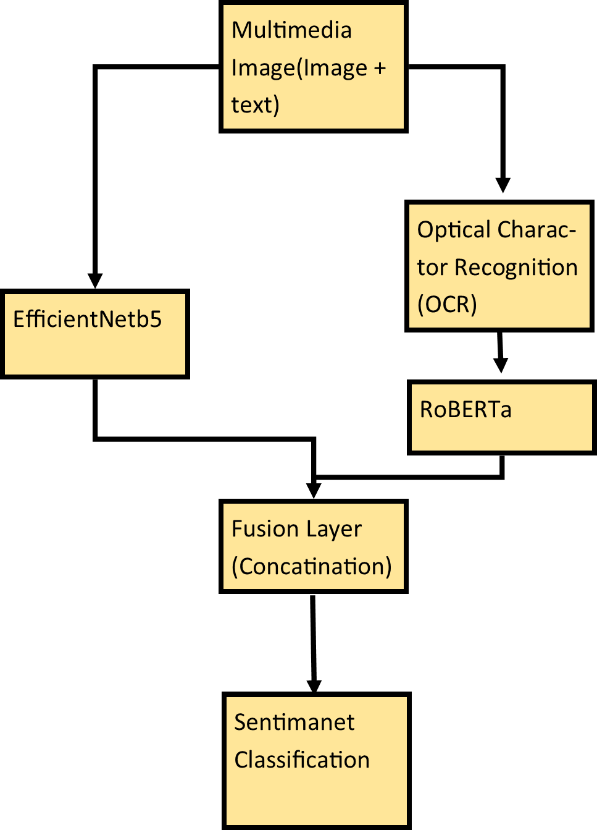

Fig. 2. Testing of Multimedia Data for Sentiment Analysis

– Evaluation of Swin and Vision Transformer
As mentioned earlier about the description of transformer model, Vision transformer[23] has successfully achieved the accuracy of 77 percent while Swin transformer 78 percent on image classification of fer2013[17] data set. We were reduces the number of classes because of lack of classes in textual data we were forced to reduce in image data set, so that pairing can easy in fusion of two different models.

Table 1. Matrix of Swin-Transformer

The validation accuracy of swin and vision transformer [12,23] in percentage are 77.58 and 77.17, performance or prediction of both models on unseen data is lie at the same level. The validation data set has 900 images of each class, model well predicts the happy class but confuse in between sad and neutral we were looked. swin transformer[12] is evaluated over 50 epochs where as vision transformer[23] trained upto the 70 epochs.
The given Fig.3 shows the evaluation of swin transformer model[12], Left section of the graph shows the training and validation loss. The decreasing loss over epoch is indicating the model’s learning capability. While in the right part of the graph shows the changes in training and validation accuracy with respect to epoch, as we can clearly observe that training accuracy starts from 0.64 and validation accuracy initiates nearly from 0.72, it might be because of pretrained weights of loaded model are already familiar with facial recognition.
– Evaluation of CNN models

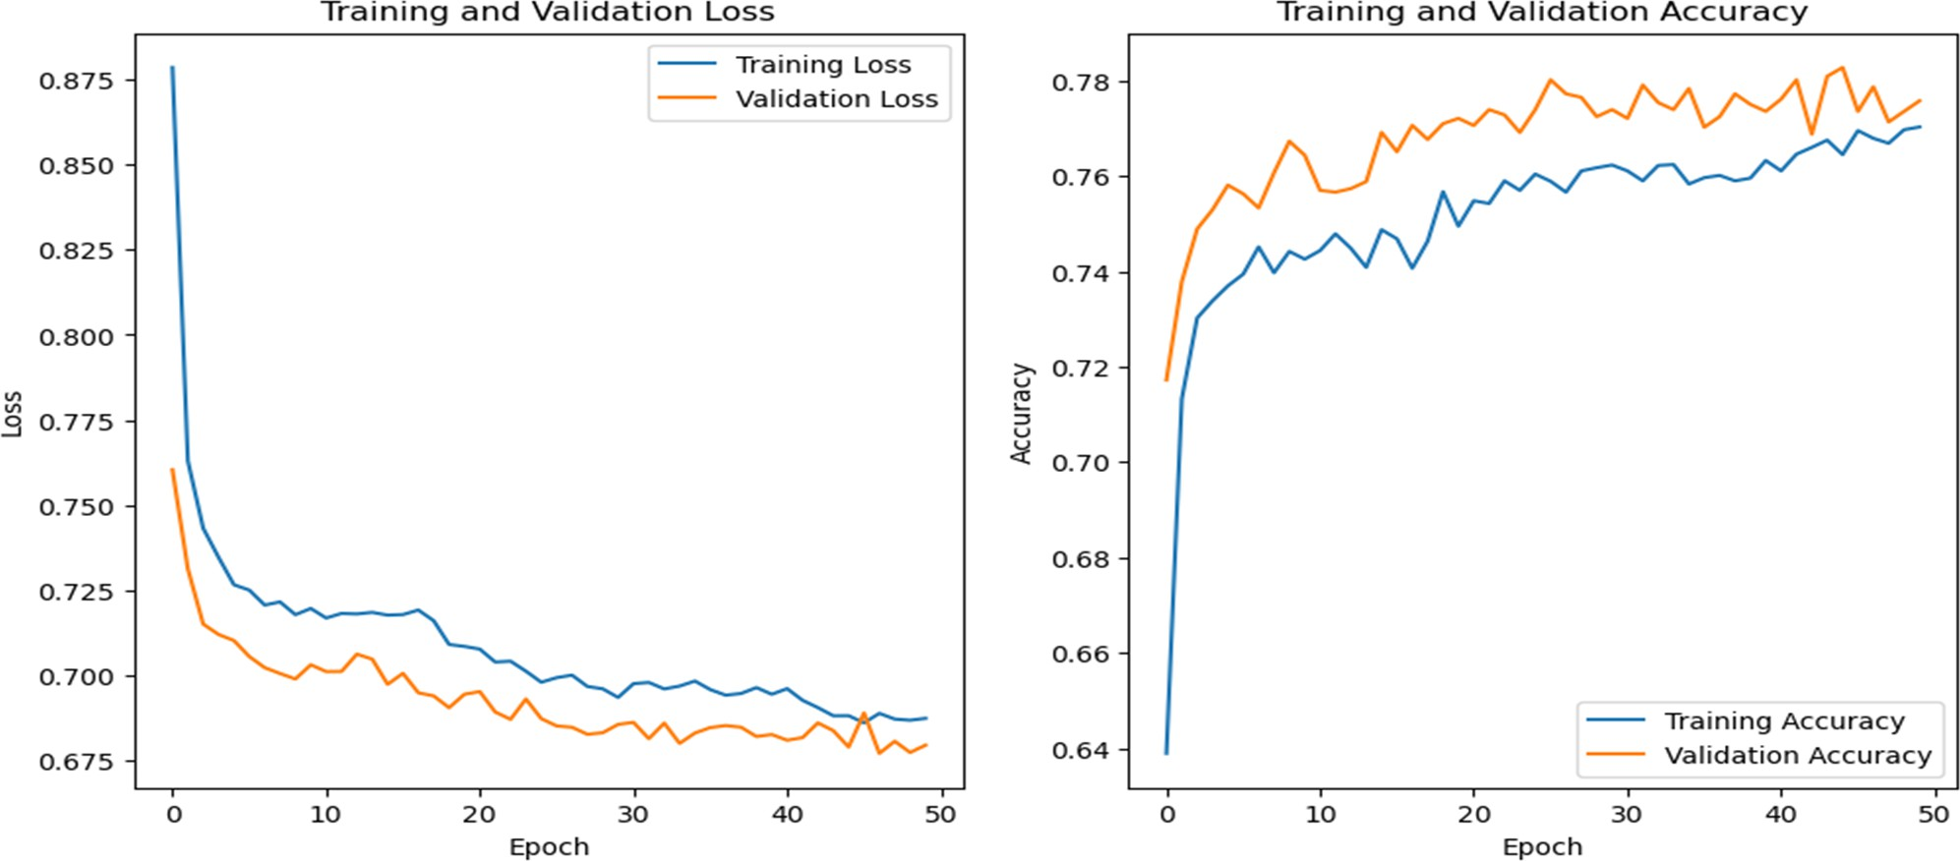

Fig. 3. Validation and Training Evaluation of Swin Transform

Table 2. Matrix of EfficientNetb5

Sentiments | Records
Sentiments | Precision | Recall | F1-Score
Happy | 0.88 | 0.91 | 0.90
Neutral | 0.77 | 0.72 | 0.75
Sad | 0.76 | 0.73 | 0.75

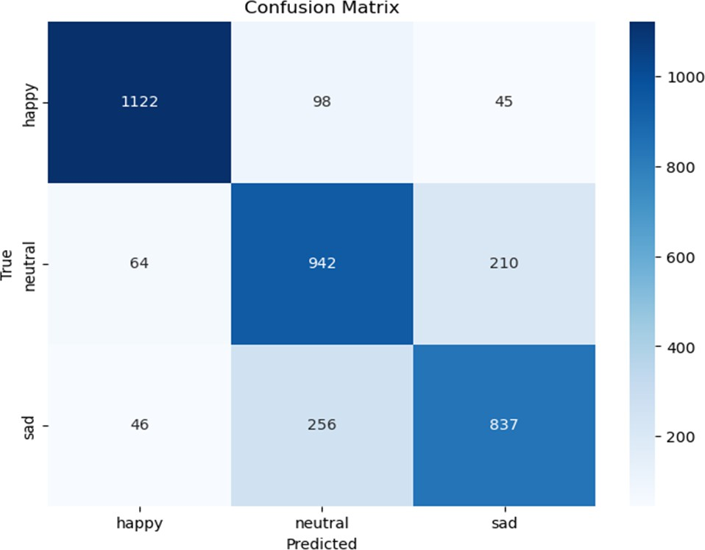

Fig. 4. Confusion Matrix

Convolutional Neural Network[22] models are capable of extracting features from the image in a hierarchical order, Therefore in facial recognition cnn is is also an acceptable approach. cnn models such as mobilenetv2, Xception, and family or versions of efficientNet[13-14]. In MobileNetV2 training accuracy reaches to 78 percent where as validation accuracy 73 percent over the 20 epochs. learning rate were scheduled as initiated from e-3 and decreases after no updates over 3 epochs minimum learning rate also set at e-6. In the first attempt of evaluation after 10 epoch Validation accuracy was stuck or shows extremely low variation where as training accuracy shows linear graph. and then we introduced data augmentation and early stop method with patience 5 in the updated code and we see improvement in evaluation.
EfficientNetb3 perform better on fer13[14] as compare b0, over the evaluation of 70 epochs training accuracy touches 75 percent and validation accuracy touches 73 percent. Similarly EfficientNetb4 and EfficientNetb5 shows quit bettre result.
Table II describe the matrix of EfficientNetb5 after evaluating on validation data set, validation data set consist of 1200 images for each classes.
Fig.4 is the confusion metrix of EfficientNetb5.
Table 3 consist the training accuracy, validation accuracy and time taken for evaluation of each individual models.

Table 3. Model Evaluations

Models | Accuracy(in percent) And Time
Models | Training | Validation | Time(h)
Xception | 81.67 | 76.55 | 20
MobileNetV2 | 77.87 | 73.76 | 13
EfficientNetb0 | 55.83 | 58.59 | 13
EfficientNetb3 | 72.28 | 73.01 | 25
EfficientNetb4 | 83.87 | 78.48 | 45.5
EfficientNetb5 | 82.64 | 80.03 | 37
EfficientNetb6 | 71.03 | 75.11 | 13
Vision Transformer | 76.81 | 77.17 | 13.5
Swin Transformer | 77.03 | 77.58 | 16
Roberta | 82 | 86.94 | 17.6

Results

After evaluating all CNN and transformer models on FER2013 and IMDB datasets, RoBERTa performed the best in textual sentiment classification, yielding 86.94% validation accuracy. EfficientNetb5, among CNN models for image classification, yields around 82% training accuracy and 80% validation accuracy. Swin transformer performs 77.58% and Vision transformer 77.17% approx. Some of the models, such as EfficientNetb0 and b3, performed comparatively low on image features due to imbalance and low-quality data.

The confusion matrix of EfficientNetb5 is showing that happy class is well predicted, while sad and neutral have overlapping prediction because of visually similar features. The training and validation curve of Swin transformer also shows the decreasing loss and improvement in accuracy but after some epochs, it gets stuck.

Results clearly indicate that deeper and heavier networks perform well on comple

image features but require high computation. On the other hand, textual model like RoBERTa easily achieve high accuracy since the IMDB dataset is well balanced.

Conclusion
The present research shows are comparision over deep learning models for multimodel sentiment analysis. Extracting textual features and image fea- tures from multimedia data and fused them to make prediction on sentiments of the image. We have trained several deep learning models now we plan to test them on multimedia data set. Lack of multimedia data set creates barrier in proceeding the work.
We got the expected performance of model which can extract textual features from text but lag in capturing image features. We will proceed this work in future our next step will be as follows, finetune the deep learning algorithm so we can get excellence in extracting virtual features from the same image data set.

References
    - Tiruwa A, Yadav R, Suri PK (2020) Sentiment analysis: an effective way of interpreting consumer’s inclinations towards a brand. In: Suri P, Yadav R (eds) Transforming Organizations Through Flexible Systems Management. Flexible Systems Management. Springer, Singapore. https:// doi. org/ 10. 1007/ 978- 981- 13- 9640-3- 12.
    - Kauffmann E, Peral J, Gil D, Ferrández A, Sellers R, Mora H (2019) Managing marketing decisionmaking with sentiment analysis: An evaluation of the main product features using text data mining. Sustainability 11(15):4235.
    - Ansari MZ, Aziz MB, Siddiqui MO, Mehra H, Singh KP (2020) Analy- sis of political sentiment orientations on Twitter. Procedia computer science 167:1821–1828.
    - Yadollahi A, Shahraki AG, Zaiane OR (2017) Current state of text sentiment analysis from opinion to emotion mining. ACM Computing Surveys (CSUR) 50(2):1–33.
    - Ribeiro FN, Araújo M, Gonçalves P et al (2016) SentiBench - a benchmark comparison of stateof- the-practice sentiment analysis methods. EPJ Data Sci 5:23. https:// doi. org/ 10. 1140/ epjds/ s13688- 016- 0085-1.
    - Yadollahi A, Shahraki AG, Zaiane OR (2017) Current state of text sentiment analysis from opinion to emotion mining. ACM Computing Surveys (CSUR) 50(2):1–33.
    - Ortis A, Farinella GM, Battiato S (2020) Survey on visual sentiment analysis. IET Image Proc 14(8):1440–1456.
    - Gandhi A, Adhvaryu K, Poria S, Cambria E, Hussain A (2023) Multimodal sentiment analysis: A systematic review of history, datasets, multimodal fusion methods, applications, challenges, and future directions. Inf Fusion 91:424–444.
    - Multimedia Tools and Applications https://doi.org/10.1007/s11042-024- 19999-8.
    - Zhao T, Peng J, Huang Y et al (2023) A graph convolution-based het- erogeneous fusion network for multimodal sentiment analysis. Appl Intell 53:30455–30468. https:// doi. org/ 10. 1007/ s10489- 023- 05151-w.
    - Ganesh Kumar P, S, A.A.V., V, J.P. et al (2023) A context-sensitive multi-tier deep learning framework.
    - Liu, Z., Lin, Y., Cao, Y., Hu, H., Wei, Y., Zhang, Z., ... Guo, B. (2021).
Swin transformer: Hierarchical vision transformer using shifted windows. In Proceedings of the IEEE/CVF international conference on computer vision (pp. 10012-10022).
    - Tan, M., Le, Q. (2019, May). Efficientnet: Rethinking model scaling for con- volutional neural networks. In International conference on machine learning (pp. 6105-6114). PMLR.Tan, M., Le, Q. (2019, May). Efficientnet: Rethinking model scaling for convolutional neural networks. In International conference on machine learning (pp. 6105-6114). PMLR.

    - Goodfellow, I. J., Erhan, D., Carrier, P. L., Courville, A., Mirza, M., Hamner, B., ... Bengio, Y. (2013). Challenges in representation learning: A report on three machine learning contests. In Neural information processing: 20th in- ternational conference, ICONIP 2013, daegu, korea, november 3-7, 2013. Pro- ceedings, Part III 20 (pp. 117-124). Springer berlin heidelberg.
    - Chollet, F. (2017). Xception: Deep learning with depthwise separable convolu- tions. In Proceedings of the IEEE conference on computer vision and pattern recognition (pp. 1251-1258).
    - Sandler, M., Howard, A., Zhu, M., Zhmoginov, A., Chen, L. C. (2018). Mo- bilenetv2: Inverted residuals and linear bottlenecks. In Proceedings of the IEEE conference on computer vision and pattern recognition (pp. 4510-4520).
    - Devlin J, Chang MW, Lee K, Toutanova K. (2018). Bert: Pre-training of deep bidirectional transformers for language understanding. arXiv preprint arXiv: 1810. 04805.
    - Liu, Y., Ott, M., Goyal, N., Du, J., Joshi, M., Chen, D., ... Stoyanov,
V. (2019). Roberta: A robustly optimized bert pretraining approach. arXiv preprint arXiv:1907.11692.
    - Liu Y, Ott M, Goyal N, Du J, Joshi M, Chen D, Stoyanov V. (2019). Roberta: A robustly optimized Bert pretraining approach. arXiv preprint arXiv: 1907. 11692.
    - Vaswani, A., Shazeer, N., Parmar, N., Uszkoreit, J., Jones, L., Gomez, A. N., ... Polosukhin, I. (2017). Attention is all you need. Advances in neural information processing systems, 30.
    - Medhat, W., Hassan, A., Korashy, H. (2014). Sentiment analysis algorithms and applications: A survey. Ain Shams engineering journal, 5(4), 1093-1113.
    - O’shea, K., Nash, R. (2015). An introduction to convolutional neural networks. arXiv preprint arXiv:1511.08458.
    - Dosovitskiy, A., Beyer, L., Kolesnikov, A., Weissenborn, D., Zhai, X., Un- terthiner, T., ... Houlsby, N. (2020). An image is worth 16x16 words: Trans- formers for image recognition at scale. arXiv preprint arXiv:2010.11929.

